**Exp-7 Introduction to ReactJS**

**Aim:** To make a web app using ReactJS.

**Theory:**

ReactJS is a JavaScript library for building user interfaces, particularly single-page applications. Here are the concepts learned during introduction to react:

1. **Component-Based Architecture**: React applications are built using components - reusable, self-contained pieces of code that return HTML via a render function.
2. **Virtual DOM**: React creates a lightweight representation of the real DOM in memory (Virtual DOM) to optimize rendering performance. When state changes, React updates the Virtual DOM, compares it with the previous version, and only updates the necessary parts in the real DOM.
3. **Unidirectional Data Flow**: Data flows in one direction from parent to child components, making applications more predictable and easier to debug.
4. **JSX**: React uses JSX, a syntax extension that allows you to write HTML-like code within JavaScript. This gets transpiled to JavaScript before being executed by browsers.
5. **States and props**:

State is internal data that can change over time within a component

Props are inputs passed from parent to child components

**Code:  
Default:**

import { useState } from 'react'

import reactLogo from './assets/react.svg'

import viteLogo from '/vite.svg'

import './App.css'

function App() {

  const [count, setCount] = useState(0)

  return (

    <>

      <div>

        <a href="https://vite.dev" target="_blank">

          <img src={viteLogo} className="logo" alt="Vite logo" />

        </a>

        <a href="https://react.dev" target="_blank">

          <img src={reactLogo} className="logo react" alt="React logo" />

        </a>

      </div>

      <h1>Vite + React</h1>

      <div className="card">

        <button onClick={() => setCount((count) => count + 1)}>

          count is {count}

        </button>

        <p>

          Edit <code>src/App.jsx</code> and save to test HMR

        </p>

      </div>

      <p className="read-the-docs">

        Click on the Vite and React logos to learn more

      </p>

    </>

  )

}

export default App

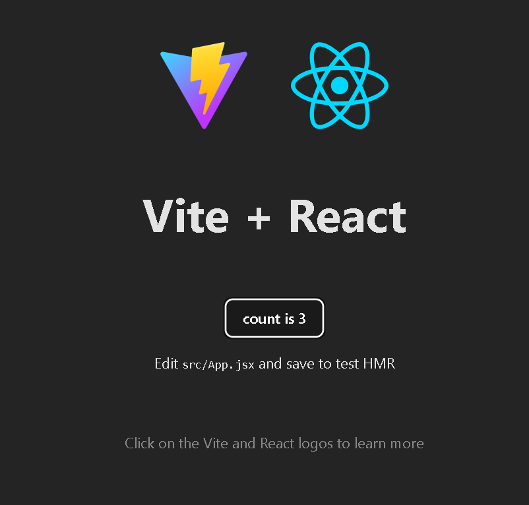

**Starting from scratch:**

**JSX:**

import './App.css'

function App() {

  return (

    <>

      <h1>Hello World</h1>

    </>

  )

}

export default App

**Output:**



**Components for navbar, header, and footer:**

**Code:**

import { useState } from "react";

import "./App.css";

import Navbar from "./components/Navbar";

import Header from "./components/Header";

import Footer from "./components/Footer";

function App() {

  return (

    <div style={{overflowY:'hidden', height:'100vh'}}>

      <Header />

      <div className="page" style={{display: 'flex', height:'100%'}}>

        <Navbar />

        <div style={{padding:'20px'}}>

          Main Content

        </div>

      </div>

      <div className="footer" style={{position:'fixed', bottom:'0px', width:'100%'}}><Footer/></div>

    </div>

  );

}

export default App;

**navbar:**

const Navbar = () => {

  return (

    <div style={{backgroundColor:'grey', width:'100px', padding:'10px', display:'flex', flexDirection:'column', gap:'20px', color:'white'}}>

      <div>Home</div>

      <div>About</div>

      <div>Contact Us</div>

    </div>

  )

}

export default Navbar

**header:**

const Header = () => {

  return (

    <div style={{backgroundColor: 'blue', color:'white', padding:'10px'}}>

      <h1>React Introduction</h1>

    </div>

  )

}

export default Header

**footer:**

const Footer = () => {

  return (

    <div style={{backgroundColor: 'cyan', color:'grey', padding:'10px'}}>

      <h3>This is footer</h3>

    </div>

  )

}

export default Footer

**Output:**

